TRICK OR TREAT HUNGER 2023
Dear Cambridge Park Neighbors,
Happy Halloween! We are your neighbors, Alex (17) and Connor (14) Bok. This year for Halloween we are again participating in Trick or Treat Hunger, a community service program coordinated through the Atlanta Community Food Bank to help provide food to those in need.
We are walking door to door to ask for support for the Atlanta Community Food Bank. If you would like to donate, please tape this flyer with the pumpkin side showing to your door on Sunday, October 29. We will collect the food on Sunday, October 29 between 11 PM and 4 PM. We ask that you please leave the food on your porch and we will collect it from there.
If it is more convenient for you to drop off your donation at our house, please put it on our front porch any time at 1520 Kadleston Way (the house on the corner of Kadleston and Stratfield).
Items in great need include:
- Peanut Butter
- Canned Tuna, Beans, Soups, Fruits and Vegetables
- Pasta and Macaroni and Cheese dinners
- 100% Fruit Juice
- Cereals
* Please no glass containers
If you cannot get to the store and want to help financially you may use the QR code below to make a donation in support of the Atlanta Community Foodbank and Trick or Treat Hunger.
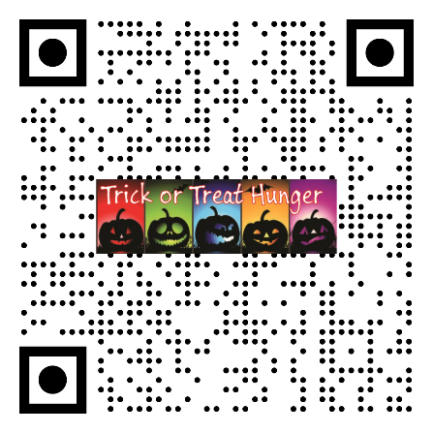
Last year we had record breaking participation. Our goal this year is to break that goal and to be the neighborhood that collects the most donations. We hope you will consider contributing to this great cause. Thank you in advance for your support!
- Alex and Connor Bok

Thank you for helping Trick or Treat Hunger for our 10th year in a row!
- Alex and Connor Bok


Alex and Connor 2023

